1.Create a ConfigMap from a directory containing multiple files and inject the variables into a pod as environment variables.
Steps:
- Create a directory
Mkdir app-config
- Create multiple files in the directory
echo "dev" > APP_ENV
echo "8080" > APP_PORT
echo "mysql-service" > DB_HOST
echo "admin" > DB_USER

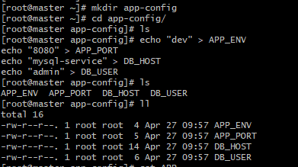

- Create ConfigMap from directory
Kubectl create cm app-config –from-file=app-config
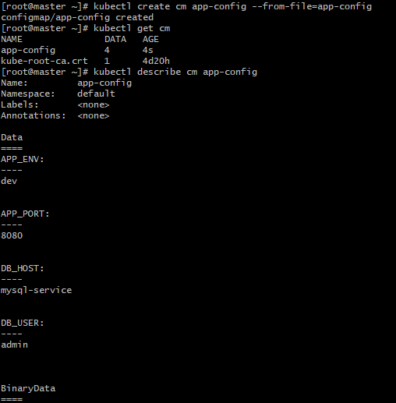

- Create Pod YAML file
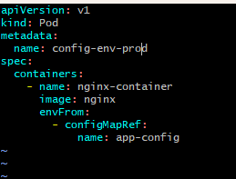

- Deploy the pod
Kubectl apply -f env.yaml
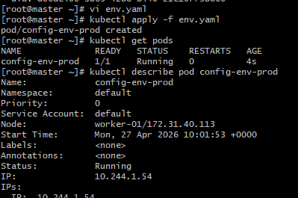

- Verify environment variables inside Pod
kubectl exec -it configmap-env-prod -- /bin/bash
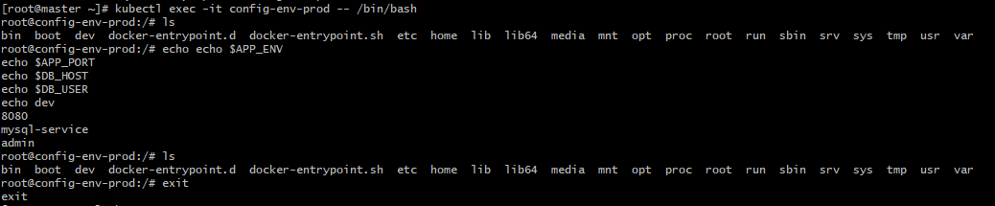

2.Create a ConfigMap from a file and mount it as a volume inside a pod, ensuring the configuration data is available as files.

Steps:

- Create one config file
Vi configfile
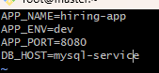

- Create ConfigMap from file
Kubectl create cm file-config –from-file=configfile
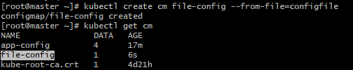

- Create Pod YAML and mount ConfigMap as volume
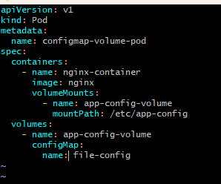

- Deploy the pod
Kubectl apply -f volume.yaml
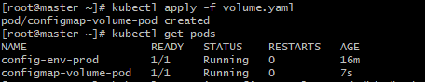
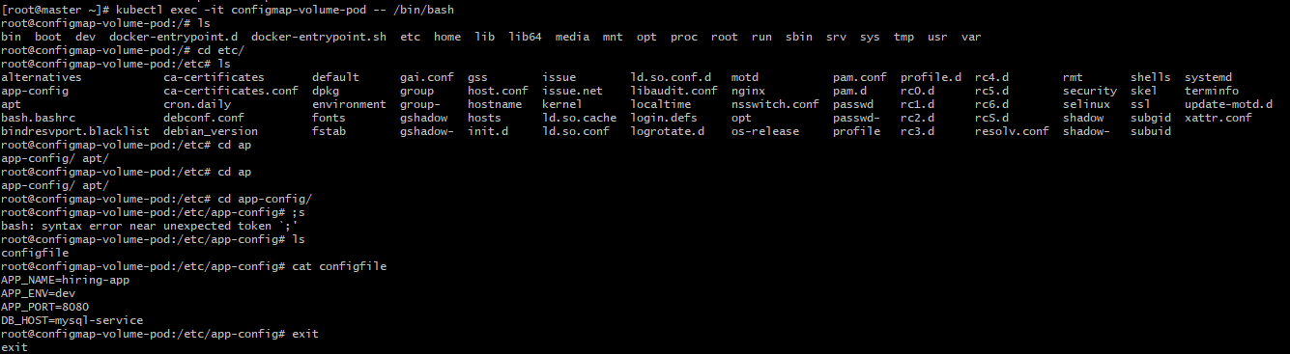

3.Create a Secret with sensitive information (username and password) and inject it into a pod as environment variables.
Steps:
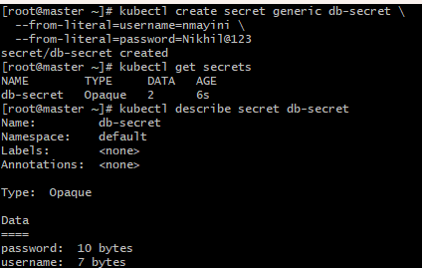
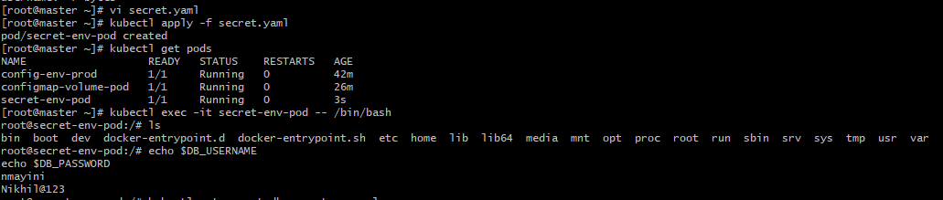
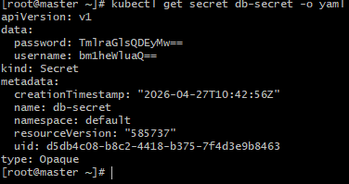

4. Create a Secret using a YAML file, mount it as a volume in a pod, and verify the specific Secret values are available as files.
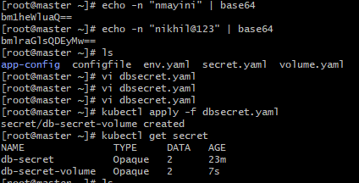
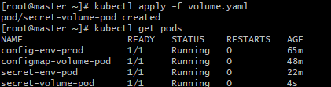
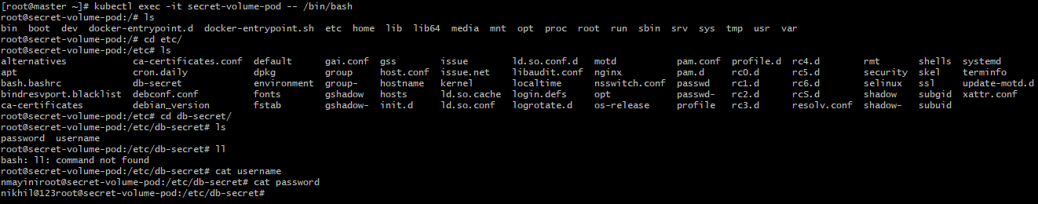

5. Inject a ConfigMap as environment variables and a Secret as files into the same pod, ensuring both are accessible within the pod.
